WORLD REGIONAL GEOGRAPHY
THERKALSEN

THE FIVE THEMES
- PHYSICAL GEOGRAPHY
  - GEOLOGY
  - CLIMATE
- POPULATION
- CULTURE
  - LANGUAGE
  - RELIGION
- GEOPOLITICS
- DEVELOPMENT

“Sub-theme” #1: GEOLOGY – Plate Tectonics
Types of Crust
THEME ONE: PHYSICAL GEOGRAPHY

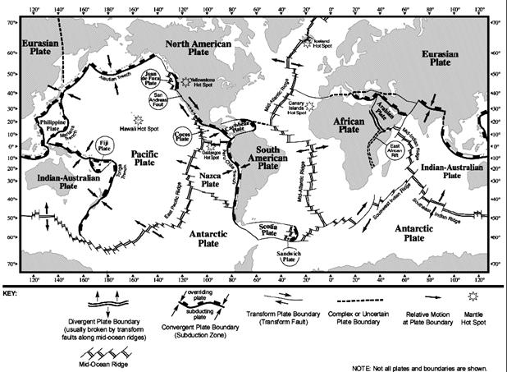
The Theory of PLATE TECTONICS: the ___________ consists of multiple __________ “plates”
- Plates are dragged by _____________in the upper _____________
These movements lead to:

HOT SPOT THEORY

Effects:

EXTERNAL FORCES:

PHYSICAL GEOGRAPHY “Sub-theme #2: CLIMATE
FIVE CLIMATE CONTROLS:
1.
2.
3.
4.
5.
1. INSOLATION -
- Function of differences in: 1. _________________ & 2. __________________
- Result of (i.e. cause of seasons): ____________ ___________ of earth as it _____________ around the sun.

- Insolation Conclusions: 1. Insolation varies by ________________
2. TOTAL annual insolation increases ___________________
3. VARIATION in annual insolation increases __________________
2. PRINCIPLE OF CONTINENTALITY - ___________ locations have a ______________ annual and daily temperature ______________ than coastal locations (__________ moderates temperature).
3. TOPOGRAPHY –

4. OCEAN CURRENTS – Redistribute energy (warm and cold water)
Flow ________________ in the Northern Hemisphere
Flow ________________ in the southern Hemisphere THUS:
*All ________ coast locations =
*All ________ coast locations =
5. GLOBAL WIND AND PRESSURE:
- Air flows from _______ pressure to ________ pressure
- Low pressure is associated with:
- High pressure is associated with:

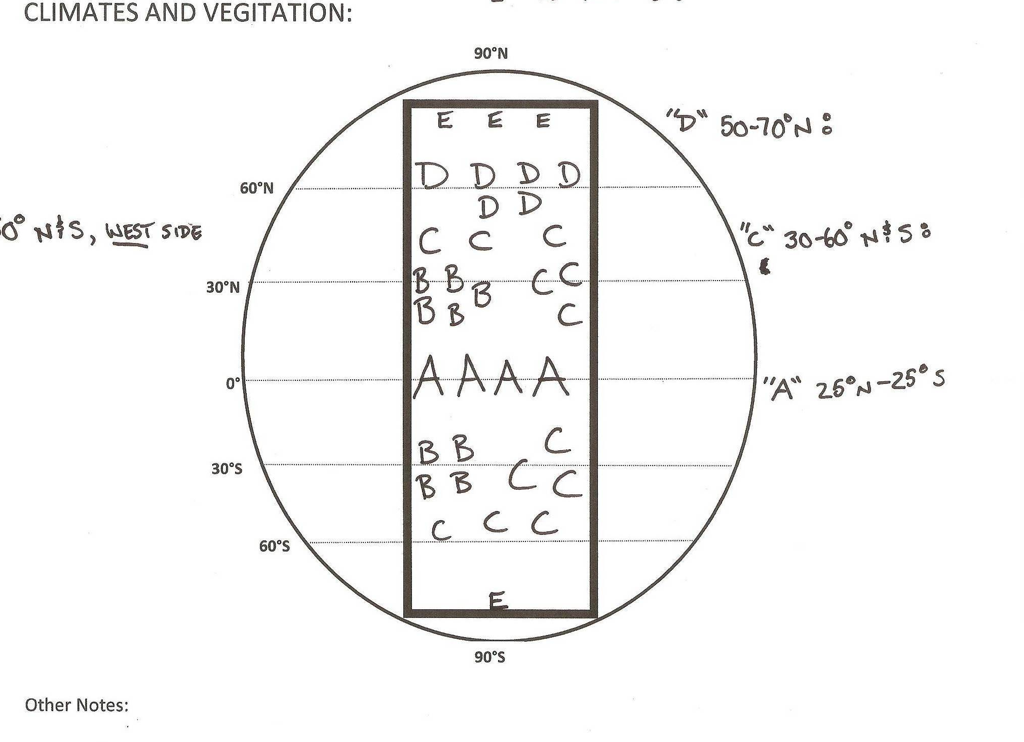
“C”30°–50° N&S:
“D” 50°–70°N:
“A” 25°N–25°S:
“E” 70-90°° N&S:
“B” 30° N&S (West Coast):
1. Land Based Issues: A) Pollution
Environmental Issues
B)
C)
2. Hydrosphere Issue: Major problem is there is ____ _______ _________water
A) Pollution (lack of clean drinking water kills ___ people every minute)
B) Privatization of water
C) ___________ in areas with limited supplies
Some Causes
- Rivers are overused, ___________ and ____________
- Leading to the disappearance of __________
- Groundwater is so overused it has led to ____________ of the land!
D) Melting __________ (these are our means of natural water __________)
- Ex: Himalayas store drinking water for ___ billion people
3. Atmospheric Issues
____________ Revolution

*___________ power *_____________ power
*___________ fuels *_____________ usage
*_____________ fuels
Fossil Fuels: Buried remains of __________ and _________ animals altered under intense heat and pressure.
1. _________
Some Issues
2. Unequal __________ and Usage
3. Environmental (burning fossil fuels releases pollution causing _____ rain, _______ and an ____________ greenhouse effect
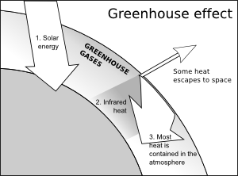
Climate Change: The “Greenhouse Effect” is a natural process in which Greenhouse gases in the atmosphere absorb energy released by the earth thus warming the atmosphere and keeping the earth at a constant livable temperature. Burning fossil fuels releases ____________________ (a greenhouse gas) into the atmosphere ENHANCING the natural greenhouse effect leading to an INCREASED warming of the atmosphere, this is the cause of _____________ ______________

CLIMATE AND VEGITATION CONCLUSIONS (test your understanding by filling in the blanks):
The 5 climate controls we discussed in class are ____________, ____________, _____________, _____________, ________________. Insolation stands for ___________ ____________ _____________ and it is hugely influential in the determination of temperature and climate. Total insolation is based mainly upon 2 variables: ___________ and ____________ and these vary based upon ___________ as a result of the earth sun relationship. Thus, we can conclude that _________ latitudes have a warmer annual temperature and a _________ temperature range. The seasons on earth are caused by the changing relationship between the earth and the sun.
Another important component of atmospheric heating is caused by gases in the atmosphere trapping energy and reradiating it back to earth, this is referred to as the ____________ effect and it is a _____________ (positive or negative) thing for humans. Often confused global warming is actually caused by an _____________ greenhouse effect when too much heat is trapped within the atmosphere.
Another important climate control is the principle of continentality which states that _________ locations have a lesser annual and daily temperature range than ___________ locations, or basically that inland locations have more ____________ temperatures. Climate may also be influenced by elevation. For example, as altitude ______________ temperature decreases and precipitation ______________. Thus higher locations tend to be ____________ and ___________ than surrounding areas. Speaking of elevation mountains also may act as a barrier to precipitation and influence temperature as air rises and sinks. As a result the windward side of a mountain is usually _______ wet than the leeward side which is usually very ________; this phenomenon is referred to as the ______________ effect.
Ocean Currents are also highly influential. As a result of the rotation of the earth ocean currents flow in a _______________ direction in the Northern hemisphere and a _________________ direction in the southern hemisphere. This causes _________ coast locations everywhere in the world to receive warm water currents and thus have _________ temperatures, more humidity, and ____________ precipitation. Meanwhile west coast locations receive ________ water currents and thus tend to have ___________ temperatures, and much less ____________.
The last control on climate we spoke of was global wind and atmospheric pressure. We discovered that air flows from _________ pressure to _________ pressure and that _________ pressure is associated with rising air and thus clouds and precipitation while _________ pressure is associated with sinking air and thus clear skies and no precipitation. The global pressure pattern indicates that there is usually low pressure over the equatorial regions and this explains why there are usually very __________ levels of precipitation. While ________ pressure centered at 30°N and S should indicate ________ skies and ________ precipitation. High pressure at the poles also leads to little precipitation and ________ pressure centered around the midlatitudes brings more weather and precipitation. These global wind and pressure belts also shift seasonally along with the ___________ ____________; this is important to understand because it leads to a shift in the direction of winds, referred to as the ______________ which can bring drastic changes in precipitation integral to life in many places.
As a result of our understanding of climate we can make the following classifications regarding global climates and vegetation:
“_________ climates” (A): 25°N-25°S; warm with abundant precipitation; Rainforest vegetation
“______ mid-latitude Climates” (C): 30-50°N and S; seasonal temperature changes; moderate/abundant precip. (_______ ocean current); mixed forest vegetation.
“Dry Climates” (B): 30°N and South, ________ coast; hot, _________ precipitation as a result of the ________ ocean current; desert/scrub vegetation.
“Severe or upper mid latitude” (D): 50-70°N and S; extreme winters; ________ forest vegetation
“________ Climate” (E): 70-90°N and S; always cold; _________/ice caps.
THEME TWO: POPULATION GEOGRAPHY
Use your book or other resources to define the following:
1. Arithmetic density (population density):
2. Physiological density:
3. Crude Birth Rate (CBR):
4. Total Fertility Rate (TFR):
5. Crude Death Rate (CDR):
6. Infant Mortality Rate (IMR):
7. Life Expectancy (LE):
8. Rate of Natural Increase (RNI):
9. Dependency Ratio:

DEMOGRAPHIC TRANSITION THEORY
Stage 5 (?)

STAGE 5
CBR___CDR
________ RNI
_______ GROWTH

STAGE 4
_______CBR &CDR
________ RNI
_______ GROWTH

STAGE 3
____________CBR
__________ GROWTH
______________RNI
Requires __________
Changes
STAGE 2
_____________DEATH RATE
________________ CBR
______________GROWTH
__________________RNI
EX: ____________ Revolution

STAGE 1
MOST OF HISTORY
WILD FLUCTUATIONS
_____ LIVING CONDITIONS
LACK OF ______________
___________CBR &CDR
________ GROWTH

INCREASING

OTHER NOTES:
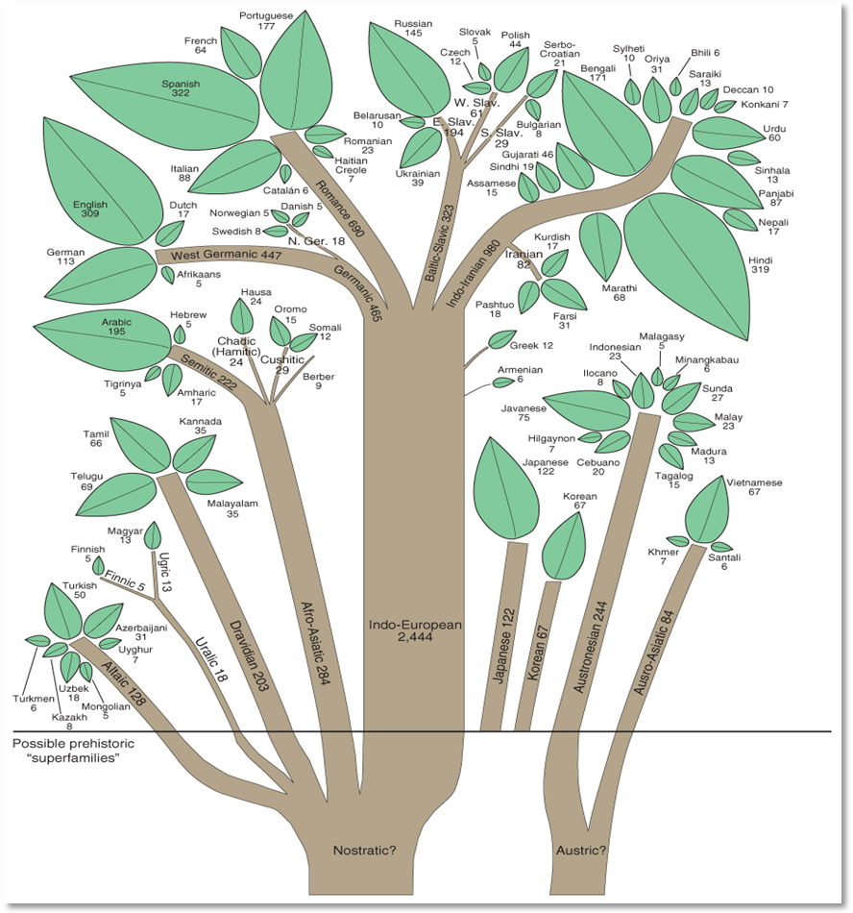
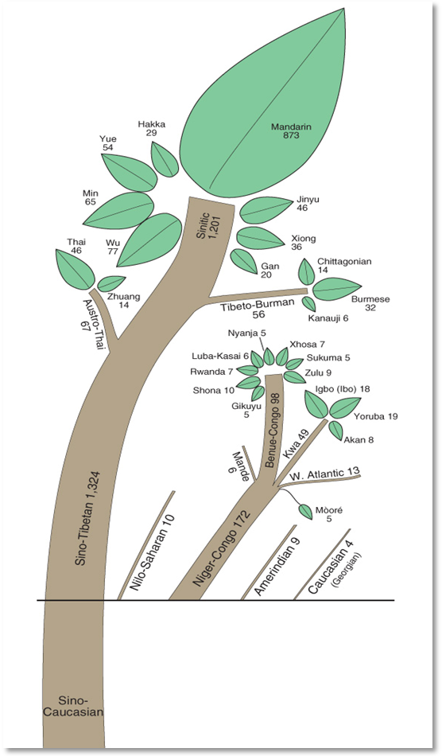
THEME THREE: CULTURE (religion and language)

50BCE

EVOLUTION OF ENGLISH LANGUAGE

RELIGION
Christianity
FOUNDED:
FOUNDER: Jesus Christ
MAJOR SCRIPTURE:
ADHERENTS:
BRANCHES: Roman Catholic, Eastern Orthodox, Protestant

SYNOPSIS
Christianity is a monotheistic and Abrahamic religion based on the life and teachings of Jesus as presented in gospels and other New Testament writings. The mainstream Christian belief is that Jesus was the Messiah prophesied in the Hebrew Bible, referred to as the "Old Testament" in Christianity, and was the Son of God, fully divine and fully human and the saviour of humanity.
The foundation of Christian theology is expressed in the early Christian ecumenical creeds which contain claims predominantly accepted by followers of the Christian faith. These professions state that Jesus suffered, died, was buried, and was resurrected from the dead in order to grant eternal life to those who believe in him and trust him for the remission of their sins (salvation). They further maintain that Jesus bodily ascended into heaven where he rules and reigns with God the Father. Most denominations teach that Jesus will return to judge all humans, living and dead, and grant eternal life to his followers.
Christianity began as a Jewish sect in the mid-1st century. Originating in the Levant region of the Middle East (modern Israel and Palestine), it quickly and by the end of the 4th century had become the official state religion of the Roman Empire. It then Spread across Europe with the Romans and later spread worldwide during the era of colonization and beyond.

Islam
FOUNDED:
FOUNDER:
MAJOR SCRIPTURES:
ADHERENTS:
BRANCHES:

SYNOPSIS
Islam means "submission," or surrender to the will of God, called Allah in Islam. Those who submit are called Muslims. Islam is a monotheistic and Abrahamic religion articulated by the Qur'an, a text considered by its adherents to be the verbatim word of God. The core beliefs of Islam are that there is only one god – unitary and beyond comprehension – and that Muhammad is the prophet of God, the last in a series of prophets beginning with Adam. The Qur'an is upheld as the eternal, literal word of God, and revelations to earlier prophets, as seen in the Jewish Torah and Christian Gospels, are believed to have become distorted by human intervention. Muslims believe that the Qur’an was revealed to Muhammad through the angel Gabriel.
Islam is based upon five "pillars," or principal acts of faith to which every Muslim adheres. These are:
1) Faith in Allah: There is no God but Allah and Mohammed is his messenger
2) Praying ____ times daily: kneeling in the direction of Mecca, the holy city.
3) Giving of Alms: a share of each Muslim's income is given to support the mosque or the poor.
4) Fasting during ______________:nothing passing the lips from sunrise to sunset
5) _____________ to Mecca: the binding force of the peoples who have embraced Islam. At least once in life every believer, physically and materially able to do so, should go to Mecca.

Adam and Eve
Abrahamic Family Tree

Abraham is recognized as the first Jew (the first ”chosen” one) because he is the person that God chose to act as an example of goodness and holiness for the rest of the world to follow. Abraham went on to teach others that there was just one God, not many, as people had believed in the past.In return for promoting this monotheistic faith Abraham is said to have been rewarded with many children who would continue to promote the idea of one almighty God.
The word that Abraham’s children and grandchildren preached attracted many believers and soon Judaism became a powerful religion, but some time around 900 BCE everything is said to have fallen apart. Jewish communities were separated and some Jews were exiled, while others were sent into slavery in Egypt.
It was Moses who is said to have been eventually sent by God to free the enslaved Jews in Egypt. Moses led the Jews out of slavery and back to a Holy Land that they had been promised by God.
On the way to the Holy Land God spoke to Moses on the top of Mount Sinai and gave him a set of rules that he said all Jews should abide by. These rules had to do with everything from diet to family relationships, but Jews observe each of these rules differently depending on whether they are Orthodox or Liberal Reformists.
Christianity, Islam and Judaism all recognize Adam and Eve and Abraham as prophets. Christianity started as a Jewish sect which recognized Jesus as the foretold coming Messiah; the last prophet who was sent to free the Jews from Roman rule. After gaining a following Jesus was crucified by the Romans and his words were later recorded by followers in versions of the Bible. While Islam shares the Jewish tradition that the first prophet is Adam, it differs in that the last prophet is Muhammad. Mohammed heard the word of God through the angel Gabriel and this is recorded in the Koran.
Judaism
FOUNDED:
FOUNDERS:
MAJOR SCRIPTURE:
ADHERENTS: About _____ million worldwide, over half in the United States.
BRANCHES: Jews are divided into Orthodox, Conservative and Reform branches,

SYNOPSIS
The religion of the Jews is inseparable from their history as a people. Much of the Torah traces the ancestry of Abraham through Isaac, Jacob, Joseph and finally to Moses, the foremost of God's prophets in Hebrew history. It was Moses who conveyed to Judaism the Ten Commandments given by God and established the religious laws and traditions.
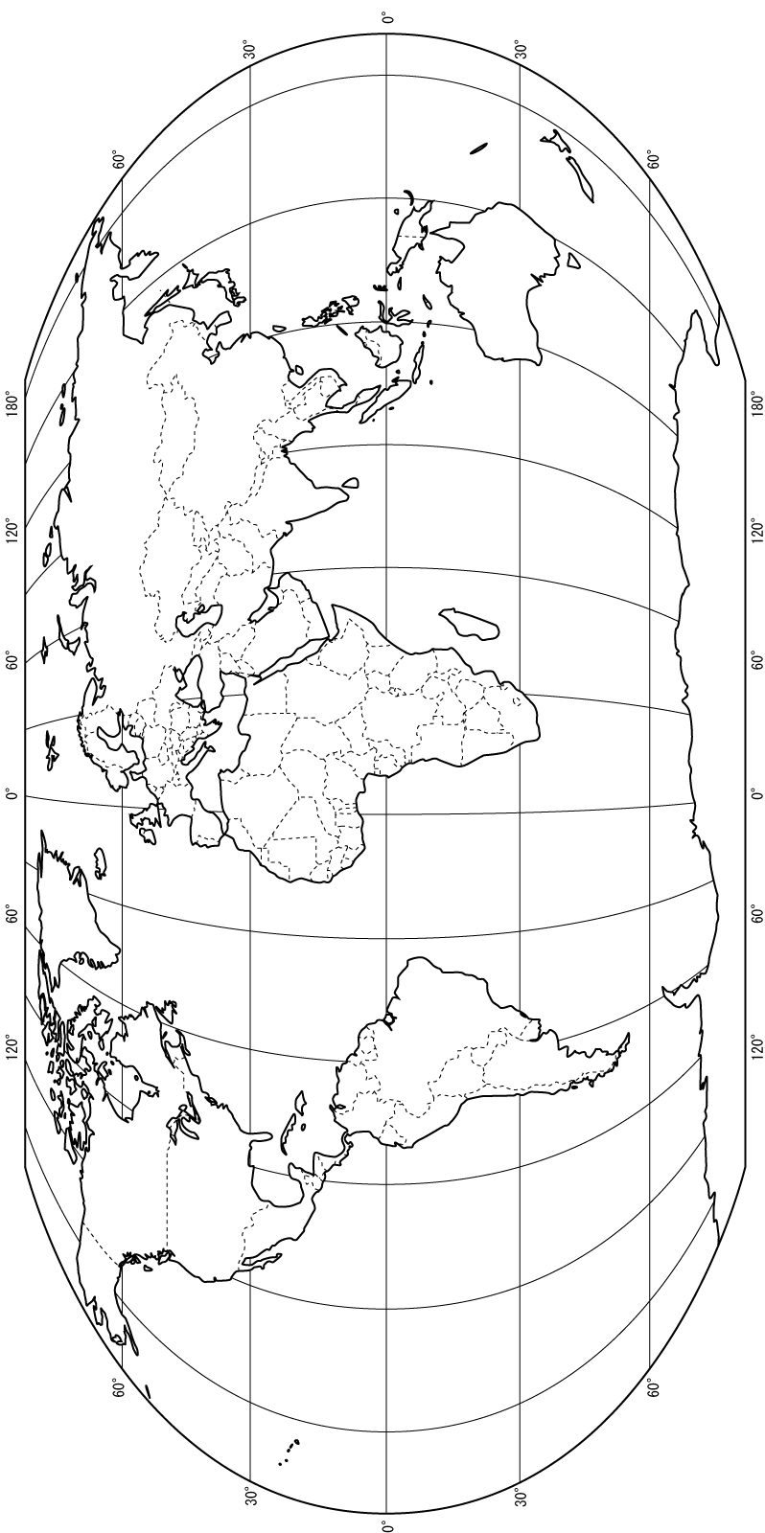
The Torah (literally, "Doctrine," "Teaching," "Law") consists primarily of the written Torah, i.e. the Hebrew Bible, or the Old Testament. By far the most profound characteristic of Judaism is its strict monotheism. The Jews hold an unshakable belief in one God and one God only, known as Yahweh, "whose name cannot be taken in vain," and from whom all creation flows. The Jewish people consider themselves a chosen people, apart from all the other peoples of the Earth, by virtue of their covenant with Yahweh. Much stress is placed on the hallowing of daily existence, worship in the synagogue, prayer and reading of the scriptures

Buddhism

FOUNDED:
FOUNDER:
MAJOR SCRIPTURES:
ADHERENTS:
BRANCHES: Buddhism today is divided into three main branches: Theravada or Hinayana (Sri Lanka, Thailand, Burma, Cambodia), Mahayana (China, Japan, Vietnam, Korea), and Vajrayana (Tibet, Mongolia and Japan).

SYNOPSIS

The primary goal of the Buddhists is to escape the cycle of ________________, a state called “_____________”, defined as the end of change, literally meaning "blowing out," as one blows out a candle. Theravada tradition describes the indescribable as "peace and tranquility." The Mahayana and Vajrayana traditions view it as "neither existence nor nonexistence," "emptiness and the unchanging essence of the Buddha" and "ultimate Reality." It is synonymous with release from the bonds of desire, ego, suffering and rebirth. Buddha never defined nirvana, except to say, "There is an unborn, an unoriginated, an unmade, an uncompounded," and it lies beyond the experiences of the senses. Nirvana is not a state of annihilation, but of peace and reality.
Life's goal is nirvana. Toward that end, Buddha's teachings are capsulized in the Four Noble Truths:
- THE TRUTH OF SUFFERING: _______________, is the central fact of life. Being born is pain, growing old is pain, sickness is pain, death is pain. Union with what we dislike is pain, separation from what we like is pain, not obtaining what we desire is pain.
- THE TRUTH OF THE ORIGIN OF SUFFERING: The cause of suffering is _____________ for sensual pleasures, for existence and experience, for worldly possessions and power. This craving binds one to the wheel of rebirth, samsara.
- THE TRUTH OF THE CESSATION OF SUFFERING: Suffering ends only with complete cessation of _____________.
- THE TRUTH OF THE PATH TO ENDING SUFFERING: The means to the end of suffering is the Noble Eightfold Path (arya ashtanga marga), right belief, right thought, right speech, right action, right livelihood, right effort, right mindfulness and right meditation.

Hinduism
FOUNDED:
FOUNDER: Unknown
MAJOR SCRIPTURES:
ADHERENTS:
BRANCHES: Many

SYNOPSIS

Hinduism is a vast and profound religion. It worships one Supreme Reality (called by many names) and teaches that all souls ultimately realize Truth. There is no eternal hell, no damnation. Each soul is free to find his own way, whether by devotion, austerity, meditation (yoga) or selfless service. Stress is placed on temple worship, scripture and the guru-disciple tradition. Festivals, pilgrimage, chanting of holy hymns and home worship are dynamic practices. Love, nonviolence, good conduct and the law of dharma define the Hindu path. Hinduism explains that the soul reincarnates until all karmas are resolved and Moksha is attained. As opposed to Buddhism within Hindusim only those within the highest casted can escape the cycle of reincarnation to reach Moksha. Movement “up or down” the caste levels is governed by how well one follows their “Dharma” (specific rules for their caste); those who follow the rules will have good “Karma” and move “up caste” and vice versa.

NOTES:

Confucianism
FOUNDED:_________________
FOUNDER: Supreme Sage K'ung-fu-tsu (Confucius) and Second Sage Meng-tzu (Mencius).
MAJOR SCRIPTURES: The Analects, Doctrine of the Mean, Great Learning and Mencius.
ADHERENTS: ___________
BRANCHES: There are no formal branches within Confucianism.

SYNOPSIS
Confucianism is, and has been for over 25 centuries, the dominant philosophical system in China and the guiding light in almost every aspect of Chinese life. Confucius and his followers traveled throughout the many feudal states of the Chinese Empire, persuading rulers to adopt his social reforms. They urged individuals to strive for perfect virtue, righteousness (called Yi) and improvement of character. They taught the importance of harmony in the family, order in the state and peace in the Empire, which they saw as inherently interdependent. Teachings emphasize a code of conduct, self-cultivation and propriety -- and thus the attainment of social and national order. Stress is more on human duty (such as public service) and the ideal of the "superior man" than on a divine or Supramundane Reality. Still, Confucius fasted, worshiped the ancestors, attended sacrifices and sought to live in harmony with Heaven.
Shintoism
FOUNDED: ________________
FOUNDER: Each of the thirteen ancient sects has its own founder.
MAJOR SCRIPTURES: Kojiki (Record of Ancient Things), Nihongi (Chronicles of Japan), a later work, Yengishiki (Institutes of the period of Yengi), and the Collection of Ten Thousand Leaves are the primary works, but they are not regarded as revealed scripture.
ADHERENTS:________________

SYNOPSIS
Shinto (from the Chinese characters Shen and Tao, signifying the "Way of the Spirits") is called Kami-no-michi in vernacular Japanese. Kami are the innumerable Gods or nature spirits. Shinto shrines are many, over 100,000 in Japan. In the shrines no images are worshiped, rather it is considered that the Kami themselves are there. Fresh foods, water, incense, etc., are offered daily upon the altar. There is an inward belief in the sacredness of the whole of the universe, that man can be in tune with this sacredness. Stress is placed on truthfulness and purification through which man may remove the "dust" which conceals his inherently divine nature and thus receive the guidance and blessings of Kami. The Shintoist's ardent love of the motherland has found unique expression in the loyalty and devotion of the Japanese people to their state institutions.

LOCALIZED INDIGENOUS RELIGIONS:
Major Locations:
Adherents:
Other Notes:

THEME 5: DEVELOPMENT
Use your book or other resources to define the following (1-8)
1. Gross Domestic Product (GDP):
2. Gross National Income (GNI):
3. Gross National Income Per Capita (GNI per capita):
4. Purchasing Power Parity (PPP):
5. Economic Growth Rate:
6. Life Expectancy:
7. Child Mortality:
8. Adult Illiteracy Rate:
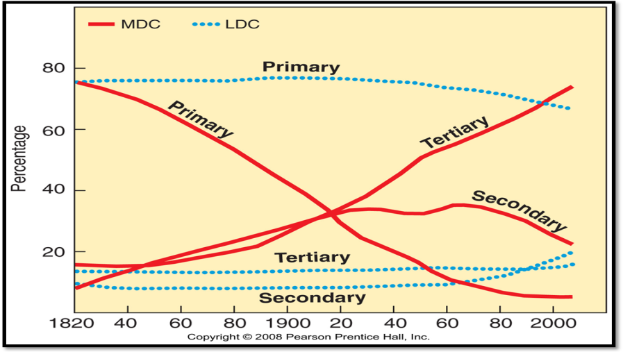
Employment
Type:

Notes:
Type of Agriculture:

“THE 5 THEMES” REVIEW QUESTIONS
INTRODUCTION TO GEOGRAPHY
1. What is geography (subfields, this class)?
2. Compare and contrast lines of latitude and lines of longitude (names, start, max, etc.)?
3. Make sure you can find locations when given coordinates and coordinates when given locations – practice using the map provided on page 2 of this handout.
THEME 1 –PHYSICAL GEOGRAPHY: GEOLOGY
1. Describe the major layers of the earth.
2. What is the theory of plate tectonics? Why is it important to understand?
3. Explain what happens along divergent (both oceanic and continental) plate boundaries.
Which direction are the plates moving relative to each other? What is driving them? What results (landforms) can be expected along this type of boundary?
4. Explain what happens along convergent (oceanic-continental and continental-continental and oceanic-oceanic) plate boundaries.
Which direction are the plates moving relative to each other? What is driving them? What results (landforms) can be expected along this type of boundary?
5. Explain what happens along transform plate boundaries
Which direction are the plates moving relative to each other? What is driving them? What results (landforms) can be expected along this type of boundary?
6. Explain the hot spot theory.
7. Where are some of the example locations on earth that have been created/influenced by these types of plate boundaries (from class)?
8. Compare and contrast the different plate boundaries!
9. Explain some of the exogenous forces that are responsible for shaping the earth (i.e. rivers, glaciers, ice sheets, etc.)

THEME 1 – PHYSICAL GEOGRAPHY: CLIMATE
1. What are the 5 major climate controls we discussed in class?
2. What is insolation? What are the variables that influence insolation? What is the cause for the seasons on earth? How does insolation influence climate/temperature?
3. What is the principle of continentality? How does it influence climate?
4. How does elevation and different topographic features (i.e. Mountains) influence climate?
5. How do ocean currents influence climates?
6. Where on earth do we find belts of high/low pressure and what climatic conditions are associated with these pressure belts? What are the monsoons?
7. Based on the variables above explain where (in terms of latitude and longitude positioning) the different climates discussed in class are found and what types of vegetation are associated with each (see: our idealized continent). How would topography change this picture?
You should really understand the five variables above and be able to APPLY them to explain why we find different climates where we do!
ENVIRONMENTAL ISSUES
1. What is deforestation and desertification?
2. What are the major “water” problems facing the world?
3. What changed with the industrial revolution and how has that influenced atmospheric problems? What is the greenhouse effect/climate change?
THEME 2: POPULATION
1. Describe the change in population over the past 1000 years? How has population changed in the last century? How many people are there in the world? Where is growth concentrated today? Who are the big 3? Where do people live and not live?
2. Define the major population terms and more importantly what these terms mean and what they tell us about the world, a country or a region? (Arithmetic density, population density, Physiological density, Crude Birth Rate (CBR), Total Fertility Rate (TFR), Crude Death Rate (CDR), Infant Mortality Rate (IMR), Life Expectancy (LE), Rate of Natural Increase (RNI), Dependency Ratio)
3. Explain in detail the demographic transition theory and how it applies to societies (which stages do we find different regions in historically and currently, why do the changes occur, etc.)
4. Migration: explain the different types, the different regions for migration (the # one reason), and historical and current migration trends.
THEME 3: CULTURE
1. What is culture? What are some examples of culture?
2. What is language? How many languages are there/Is the number increasing or decreasing? What are the top three spoken languages and Why?
3. What is the world lingua franca and Why?
4. Know a little about the major language families of the world (relationships, etc.)?
5. What is Religion? Explain the differences between Universalizing and Ethnic Religions; Provide examples of each. What does it mean to be secular?
You should be able to explain the main concepts of the major religions we covered in class:
6. Christianity- Founder, location, story, scripture, adherents, major tenets, major branches (and why/how these branches formed).
7. Islam- Founder, location, story, scripture, adherents, major tenets, major branches (and why/how these branches formed).
8. 16. Judaism- location, story, adherents, major tenets, relationship to Islam and Christianity.
9. Buddhism- Founder, location, story, scripture, adherents, major tenets.
10. Hinduism- location, adherents, major tenets.
11. Confucianism - Founder, location, adherents, major tenets.
12. Shintoism - location, adherents, major tenets.
THEME 4: GEOPOLITICS
1. What is a state vs a nation? How many “states” exist today?
2. What is a boundary and on what basis are they created?
3. Define the acronyms and briefly describe the following organizations: NATO, EU and UN.
4. Get familiar with the “global pattern of governance” (i.e. which political system dominates the western hemisphere, what’s a theocracy? Where are the remaining Monarchies, which system is China, etc.)
THEME 5: DEVELOPMENT
1. What is a MDC and LDC? How are these terms related to 1st, 2nd, and 3rd world?
2. Define the major development terms and more importantly what these terms mean and what they tell us about the world, a country or a region? (GDP, GNI, GNI per capita, PPP, economic growth rate, life expectancy, child mortality, adult illiteracy rate)
3. Where are MDCs and LDCs distributed and WHY?
4. Explain how geography/climate influenced colonial “winners” and “losers” (i.e. where do we see “full” vs “extraction” colonization?)

